**FPT ACADEMY INTERNATIONAL**



## FPT – APTECH COMPUTER EDUCATION

**INCREDIBLE BRIGDES**

|  |  |  |  |
| --- | --- | --- | --- |
| **Center Name** | | FPT – Aptech – HCM2  Address: 590 Cach Mang Thang Tam, District 3, Ho Chi Minh City | |
| **Instructor** |  | Ms. Le Mong Thuy |  |
| **Class** |  | T1.2205.M0 |  |
| **Group** |  | 4 |  |
| **Group members** | | **Name** | **Student ID** |
|  |  | Ho Dang Viet Tien | Student1384669 |
|  |  | Lam Vinh Hao | Student1381859 |
|  |  | Nguyen Phu Hao | Student1381857 |
| **Duration** | Start date | 19th August 2022 |  |
| End date | 19th September 2022 |  |

**This is to certify that**

**Mr.:**

Ho Dang Viet Tien

Lam Vinh Hao

Nguyen Phu Hao

**has successfully designed & developed**

eProject: Incredible Brigdes website

**Submitted by:**

Ho Dang Viet Tien

**Date of issue:**

19th September 2022

**Authorized Signature:**

**TABLE OF CONTENTS**

****FPT – APTECH COMPUTER EDUCATION 1****

****TABLE OF CONTENTS**** ****2****

****ACKNOWLEGMENT**** ****3****

****SYNOSIS**** ****3****

****PROBLEM DEFINITION**** ****3****

****CUSTOMER'S REQUIREMENTS SPECIFICATIONS (CRS) 4****

****Business/Project Objective**** ****4****

****Hardware/ Software Requirements**** ****5****

****SCOPE OF THE WORK (IN BRIEF) 6****

****Architecture and design of the system 7****

****Diagram of the website 8****

****TASK SHEET REVIEW 1 9****

****SITE MAP 10****

****MOCK OF THE WEBSITE 1********1****

***1. Homepage 1******1***

***2. Product 1******2***

***3. Blog 1******3***

***4. About Us 1******4***

***5. Contact US 1******5***

***6. Service 1******6***

***7. Sign In/ Sign Up 1******7***

****TASK SHEET REVIEW 2 18****

WEBSITE DESCRIPTION ****1********9****

RESPONSIVE****28****

[****JAVASCRIPT DESCRIPTION****](#Javascript) ****30****

****TASK SHEET REVIEW 3**** ****47****

# ACKNOWLEGMENT

This project consumed huge amount of work and dedication. Still, implementation would not have been possible if we did not have a support of many individuals. Therefore we would like to extend our sincere gratitude to all of them.

First of all we are thankful to Ms Le Mong Thuy for providing necessary guidance concerning projects implementation as well as her provision of expertise. Without her superior knowledge and experience, the Project could not have been successful. We also would like to express our sincere thanks towards the members of the team who devoted their time and knowledge in the implementation of this project.

Finally, we express our gratitude toward our families and colleagues for their kind co-operation and encouragement which help us in completion of this project.

# SYNOSIS

Incredible Bridges is a website which provides information about various famous bridges around the world.

Incredible Bridges offers users the opportunity to learn more about World Bridges. All of the information is well organized and put into categories so it is very easy to search for and not time-consuming.

Incredible Bridges also allows its users to share their ideas with other people who have the same interest or even with the admin. Moreover, usefull information about buses and fights to reach the places is provided as well.

# PROBLEM STATEMENT

The Web site is to be created based on the following requirements.

1. The Top of the Page should be presented with a suitable logo and various images of famous bridges.
2. Site should have sections as Historical Great Bridges, High-Level Achievements in Bridges, Iconic Bridges, and Modern Great Bridges etc.
   * Various bridges should be listed in these sections accordingly
3. Sections like Longest, Tallest, Highest, Oldest etc. to be added to the website.
4. History and information of the bridges should be added along with the images.
5. The site must contain the filter based on Continents to look for various bridges in the continent
6. Gallery can be added for viewing different images.
7. Feedback must be allowed to enter by the viewer.
8. Site map, Gallery, About us, FAQ link, Contact us link must be added.
9. About Us and Contact Us: This menu option should display Email id, address, and contact number of the organization who is developing the system.
10. The advertise section of bus, flights can be included for reaching the places.

# CUSTOMER'S REQUIREMENTS SPECIFICATIONS (CRS)

**Website: Incredible Bridges**

### Business/Project Objective:

* Provide users interesting information about famous bridges around the world.
* Enable users to search for their favorite one through its name
* Help users to identify brigdes location and find ways to reach there.

**Input to the system:**

* Feedback from visitor.

**Output from the system:**

* Detailed information about the bridges as well as illustrated pictures
* Display location of the bridges and provide information about buses and flight to reach the places
* Display a visitor count.

**Process**:

* + - * Validate data input from users.

**Expected delivery date:** 19-September-2022.

**List of deliverables:**

- Document Word, PDF.

- Source code.

Hardware/ Software Requirements:

**Hardware**

* Intel Core i3/i5 Processor or higher
* 8 GB RAM or above
* Color SVGA
* 500 GB Hard Disk space
* Mouse
* Keyboard

**Software**

Technologies to be used:

* Frontend: HTML5, CSS, Bootstrap, JavaScript, jQuery, AngularJS.
* Data Store: JSON files

Other Requirements:

* Operating Portal: Windows
* Browsers: Edge, Chrome, Mozilla Firefox, Safari

# SCOPE OF THE WORK (IN BRIEF)

After a long and detailed discussion, our group has decided to create a website contain the following webpages:

1. ***Homepage***: There is a menu bar to display 7 categories: Home, Brigdes (Historical, Iconic and Modern), Gallery, Contact us, About us, FAQ and Sign up
2. Each Bridge webpage will show 5 brigdes
3. ***Gallery:*** Displays all picture of website
4. ***About Us***: Display the information of the company
5. ***Contact Us***: Display the address of the company, Map and allow customers to request any information
6. ***FAQ***: Display some common question and answer.
7. ***Feedback***: Allow users send feedback and comment to the company.

# ARCHITECTURE AND DESIGN OF THE SYSTEM

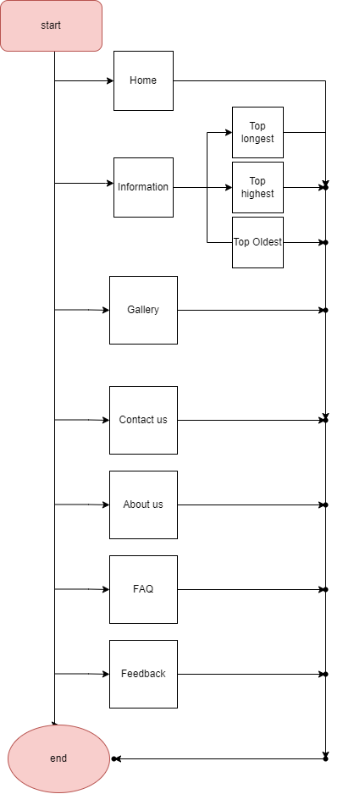



# TASK SHEET REVIEW 1

|  |  |  |  |  |  |  |  |
| --- | --- | --- | --- | --- | --- | --- | --- |
| **Project Ref. No.:**  **eP/Advertisement Portal Management**  **System/01** | | **Project Title:** | **Activity Plan Prepared By:** | **Date of Preparation of Activity Plan:** | | | |
| **Sr.**  **No.** | **Task** | **Actual**  **Start**  **Date** | **Actual Days** | **Team**  **Mate Names** | **Status** |
| 1 | Problem Statement | Incredible Bridges | Dai | 19-Aug-22 | 1 | Tien | Completed |
| 2 | Analysis equirements about the website | 19-Aug-22 | 1 | Tien | Completed |
| 3 | The scope of the work (in brief) | 19-Aug-22 | 1 | Hao | Completed |
| 4 | Architecture and design of the system | 19-Aug-22 | 1 | Hao | Completed |
| 5 | Task Sheet | 19-Aug-22 | 1 | Tien | Completed |

|  |  |
| --- | --- |
| **Date:** | |
| Signature of Instructor:  **Ms. Le Mong Thuy** | Signature of Team Leader:  **Ho Dang Viet Tien** |

# SITE MAP

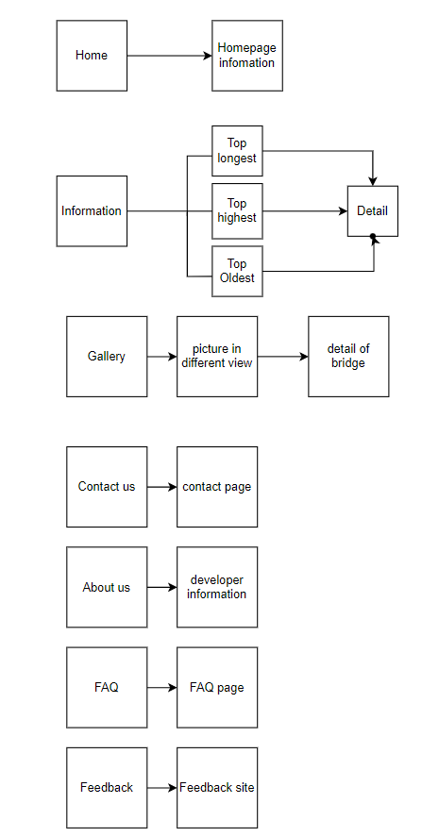

# MOCK OF THE WEB SITE

1. **Homepage**

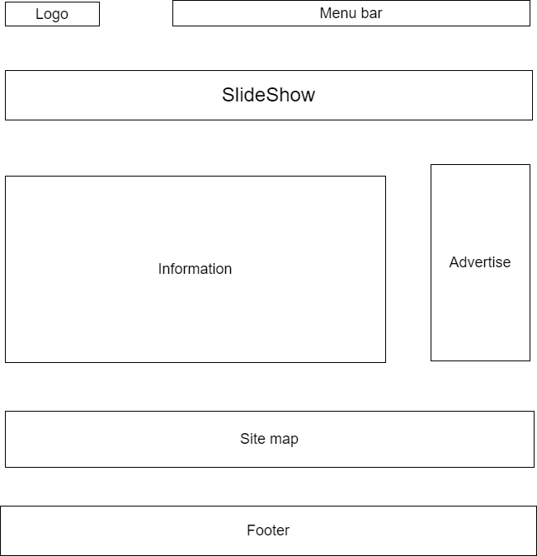

1. 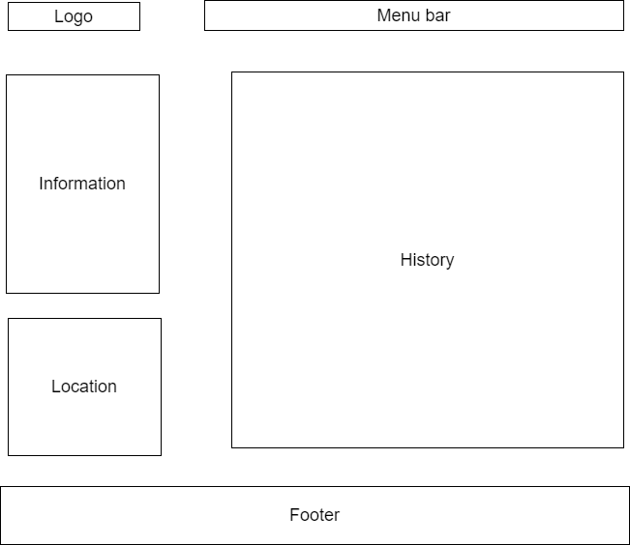**Detail Brigdes**
2. **Gallery**

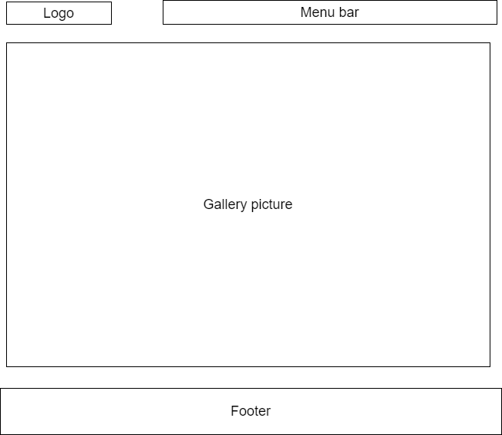

1. **About Us**

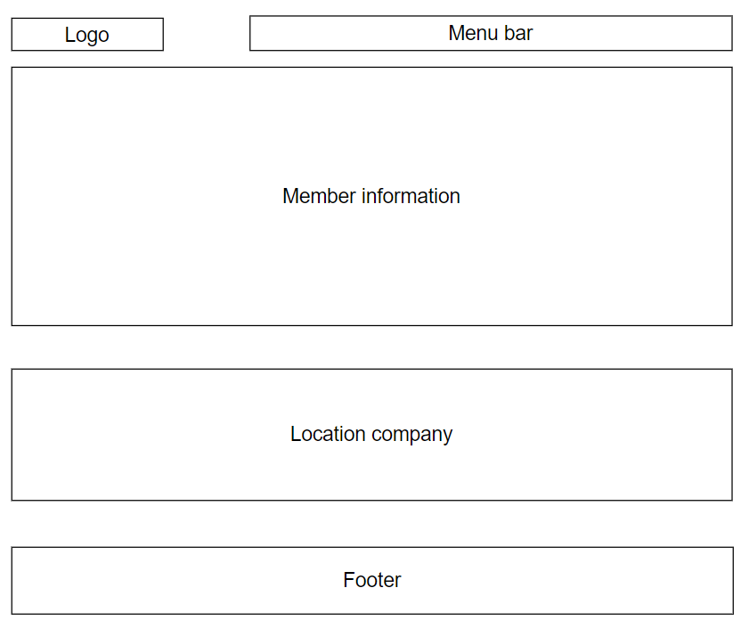

1. **Contact Us**

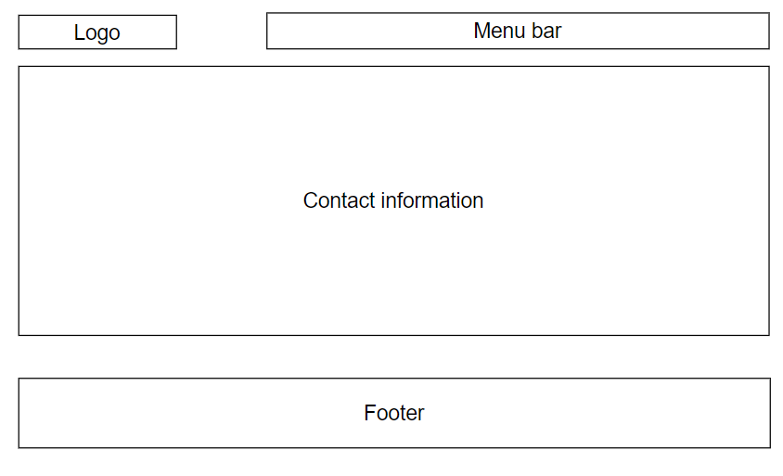

1. **FAQ**

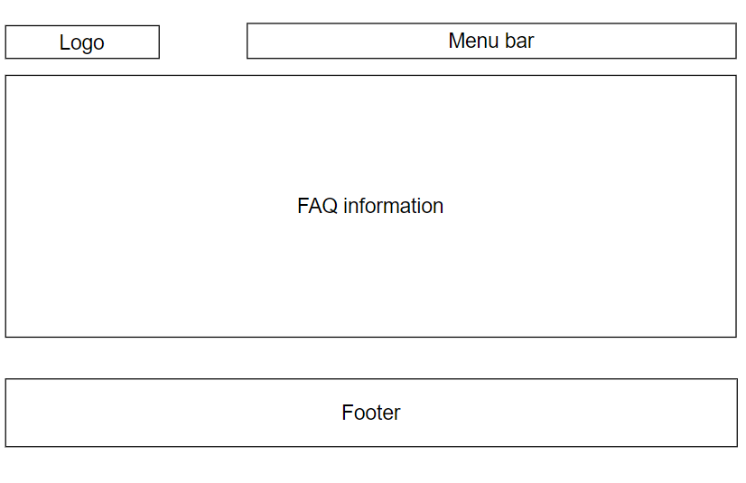

1. **Feedback**

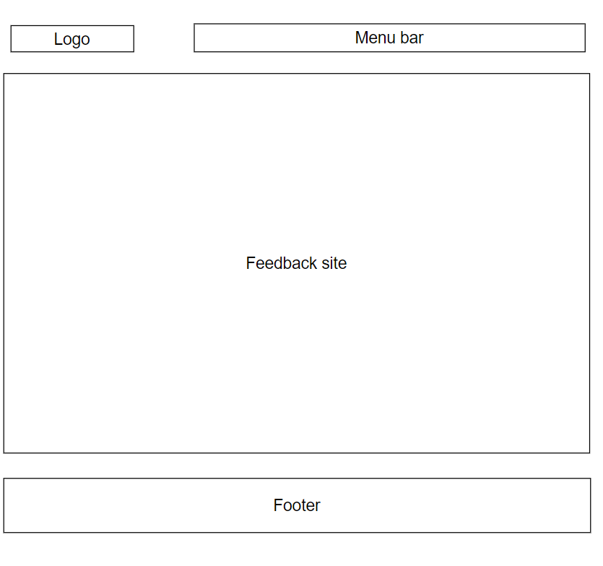

# TASK SHEET REVIEW 2

|  |  |  |  |  |  |  |  |
| --- | --- | --- | --- | --- | --- | --- | --- |
| **Project Ref. No.:**  **eP/Advertisement Portal Management**  **System/01** | | **Project Title:** | **Activity Plan Prepared By:** | **Date of Preparation of Activity Plan:** | | | |
| **Sr.**  **No.** | **Task** | **Actual**  **Start**  **Date** | **Actual Days** | **Team**  **Mate Names** | **Status** |
| 1 | Site Map | Incredible Brigdes | Tien | 23-Aug-22 | 1 | Tien | Completed |
| 2 | Mock of the website | 22-Aug-22 | 2 | Hao | Completed |
| 3 | Task sheet | 22-July-22 | 2 | Hao | Completed |

|  |  |
| --- | --- |
| **Date:** | |
| Signature of Instructor:  **Ms. Le Mong Thuy** | Signature of Team Leader:  **Ho Dang Viet Tien** |

# WEBSITE DESCRIPTION

1. **Homepage**
2. Description

Home page displays a few top famous bridges

1. 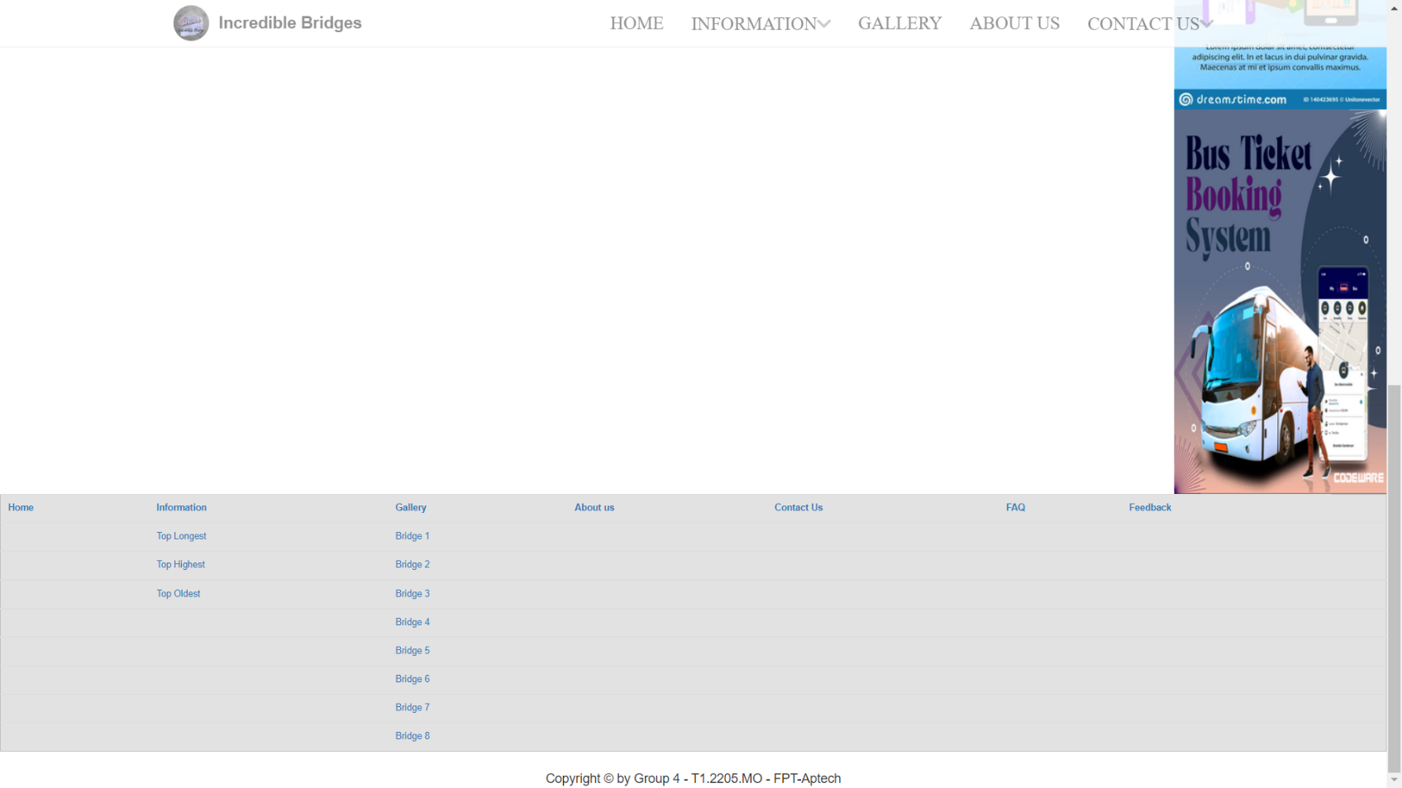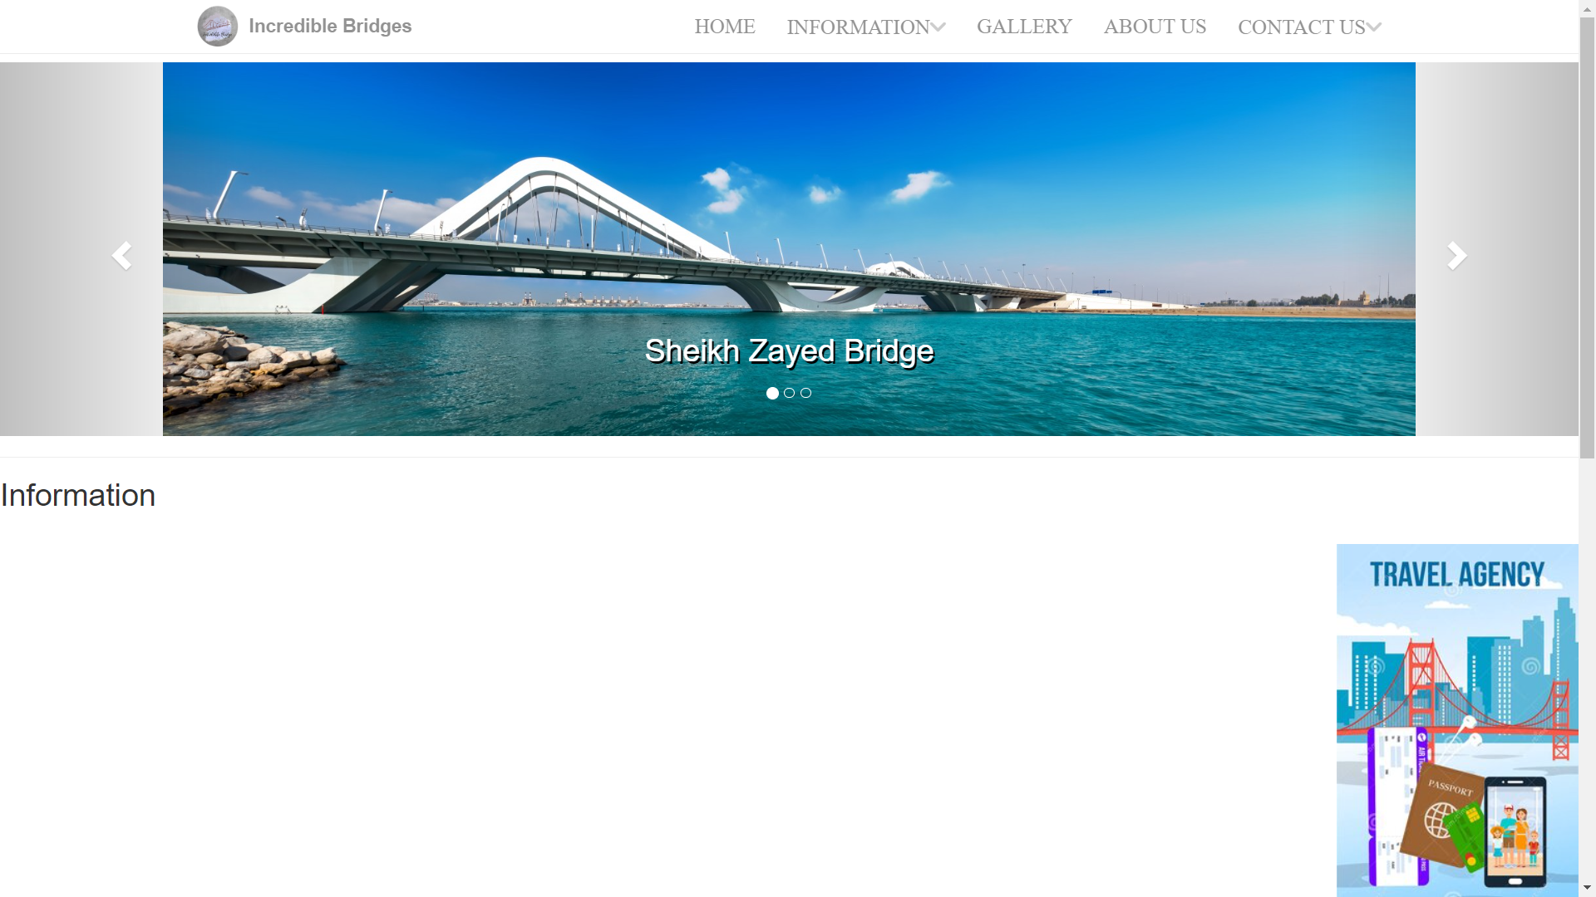Screen shot

2.Gallery

1. Description

Gallery displays the most beauty picture of bridge and linked to the detail of bridge

1. 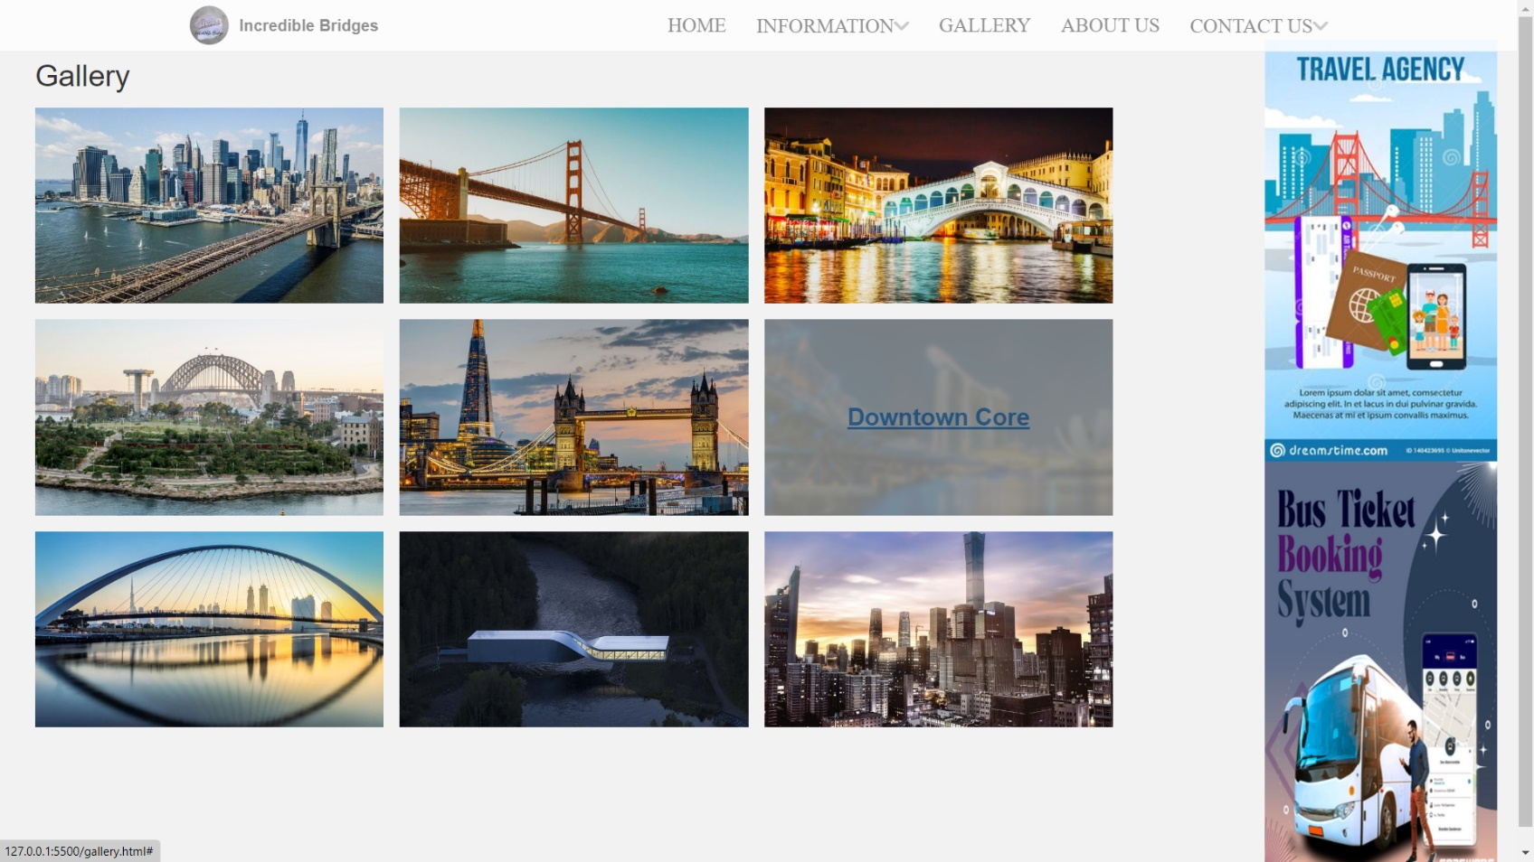Screen shot

3.Detail Bridge

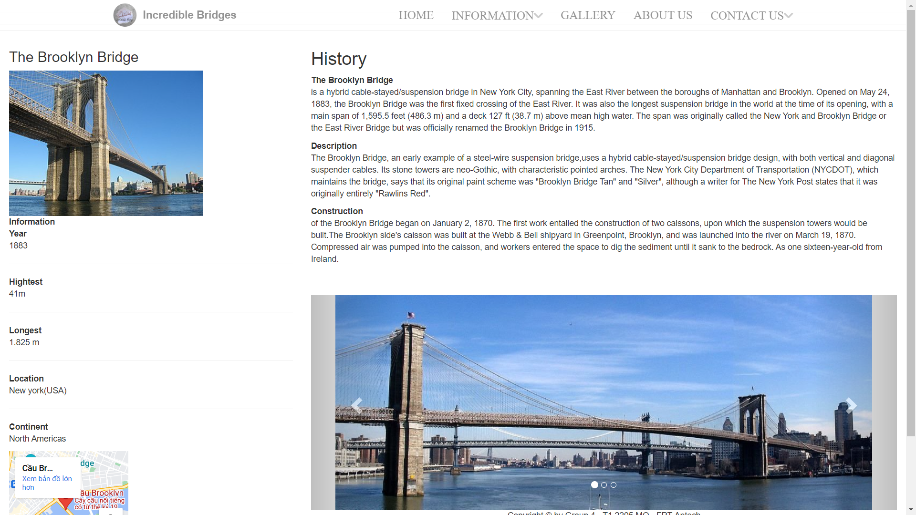

# TASK SHEET REVIEW 3

|  |  |  |  |  |  |  |  |
| --- | --- | --- | --- | --- | --- | --- | --- |
| **Project Ref. No.:**  **eP/Advertisement Portal Management**  **System/01** | | **Project Title:** | **Activity Plan Prepared By:** | **Date of Preparation of Activity Plan:** | | | |
| **Sr.**  **No.** | **Task** | **Actual**  **Start**  **Date** | **Actual Days** | **Team**  **Mate Names** | **Status** |
| 1 | Home Page | Incredible Brigdes | Tien | 23-Aug-22 | 1 | Tien | Processing |
| 2 | Detail brigde | 23-Aug-22 | 3 | Hao | Processing |
| 3 | Gallery | 23-Aug-22 | 2 | Hao | Processing |

|  |  |
| --- | --- |
| **Date:** | |
| Signature of Instructor:  **Ms. Le Mong Thuy** | Signature of Team Leader:  **Ho Dang Viet Tien** |